Oxford Real Estate Round-Up 2024
by Wayne Gauthier, Joyner Fine Properties*

Nov. 1, 2023 - Jan 31, 2024
Address | Fin SF | # Bedrooms | Style | Sales Price | Sales Date
8335 Whitewood Rd | 2446 | 3 | Tri-Level/Quad Level | $423,000 | 2023-12-04
3100 Archdale Rd | 3092 | 4 | Cape | $449,950 | 2023-11-20
8321 Trabue Rd | 3520 | 5 | Tri-Level/Quad Level | $569,000 | 2023-12-04
8524 Trabue Rd | 3333 | 4 | Cape | $635,000 | 2023-11-03

* Data taken from the Chesterfield and City of Richmond tax records and the Central Virginia Regional Multiple Listing Service. Transactions Recorded between 11/01/2023 -01-31-2024. Wayne Gauthier, Joyner Fine Properties, is a Licensed Real Estate Agent in Richmond, Virginia.

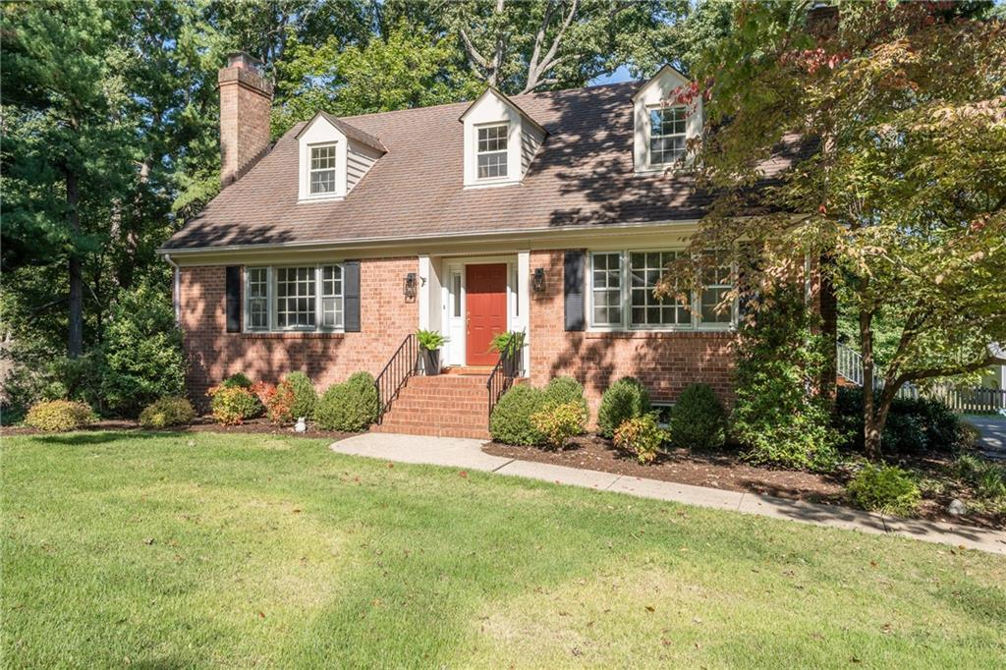

Top Sale - 8524 Trabue Rd. - One of the earlier built homes has landed as our top sale in Oxford in the last three months. This handsome Cape had a mindfully renovated kitchen and a family room in the basement that is an incredible space for lounging or entertaining. Great mature landscaping and a wonderful lot contributed to this home, taking this report's Top Sale award.

